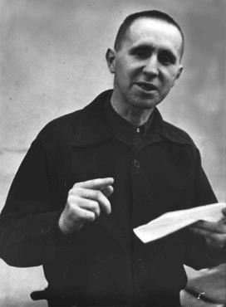
Criterion B:
Developing Skills
Achievement level | Level descriptor | Clarifications
0 | - The student does not reach a standard described by any of the descriptors below.
1 – 2 | - The student:  - demonstrates limited acquisition and development of the skills and techniques of the art form studied  - demonstrates limited application of skills and techniques to create, perform and/or present art. | Process Journal (PJ)  - Your PJ shows no evidence of your practical exploration of Epic Theatre techniques during this unit.  Final Epic Theatre Performance  - You have included less than two examples of Epic theatre techniques in your performance.  - The Epic theatre techniques utilised during were not used appropriately to distance the audience or to educate your audience on a social issue.
3 – 4 | - The student:  - demonstrates adequate acquisition and development of the skills and techniques of the art form studied  - demonstrates adequate application of skills and techniques to create, perform and/or present art. | Process Journal (PJ)  - Your PJ shows some evidence of your practical exploration of Epic Theatre techniques during this unit.  - There is reference to you acquiring individual skills such as narration, gestus and use of placards and/or projections.  Final Epic Theatre Performance  - You have used narration, gestus and placards in your performance to distance your audience and to educate your audience on a social issue.  - Although all three Epic Theatre techniques were used within your performance, not every technique was applied effectively throughout the performance.  .
5 – 6 | - The student:  - demonstrates substantial acquisition and development of the skills and techniques of the art form studied  - demonstrates substantial application of skills and techniques to create, perform and/or present art. | Process Journal (PJ)  - Your PJ shows substantial evidence of your practical exploration of Epic Theatre techniques during this unit.  - There is reference to you acquiring individual skills such as narration, gestus and use of placards and/or projections and also how you developed these skills to be able to combine them within a performance.  Final Epic Theatre Performance  - You have used narration, gestus and placards in your performance to effectively distance your audience and to educate your audience on a social issue.
7 – 8 | - The student:  - demonstrates excellent acquisition and development of the skills and techniques of the art form studied  - demonstrates excellent application of skills and techniques to create, perform and/or present art. | Process Journal (PJ)  - Your PJ shows excellent evidence of your practical exploration of Epic Theatre techniques during this unit.  - There is reference to you acquiring individual skills such as narration, gestus and use of placards and/or projections and also how you developed these skills to be able to combine them within a performance to distance and educate an audience.  Final Epic Theatre Performance  - You have used narration, gestus and placards in a variety of different ways to effectively distance your audience and to educate your audience on a social issue.  - You have also independently researched other Epic Theatre Performance techniques, other than those explored in class, and have utilised them within your final performance.

