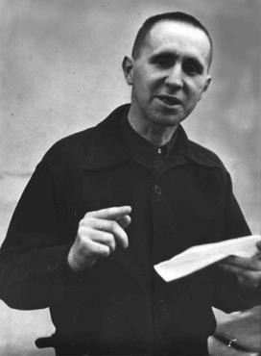
Criterion C:
Thinking Creatively

Achievement level | Level descriptor | Clarifications
0 | - The student does not reach a standard described by any of the descriptors below.
1 – 2 | - The student:  - presents a limited outline of an artistic intention, which may lack clarity or feasibility  - presents a limited outline of alternatives, perspectives, and imaginative solutions  - demonstrates limited exploration of ideas through the developmental process, which may lack a point of realization. | Process Journal  - There is a lack of practical exploration and experimentation evidenced in your process journal.  - There is limited planning for your performance work evidenced in your process journal.  - There is no self-reflection of your process to aid the development of your ideas and to enable you to find alternative or imaginative solutions.  - Your process journal shows no clear outline of the artistic intention for your final Epic Theatre performance
3 – 4 | - The student:  - presents an adequate outline of a clear and/or feasible artistic intention  - presents an adequate outline of alternatives, perspectives, and imaginative solutions  - demonstrates adequate exploration of ideas through the developmental process to a point of realization. | Process Journal  - There are some examples of practical exploration and experimentation evidenced in your process journal.  - There is some planning for your performance work evidenced in your process journal.  - There is some self-reflection of your process, which aids the development of your ideas and enables you to find some alternative or imaginative solutions.  - Your process journal shows a basic outline of your artistic intention for your final Epic Theatre performance.
5 – 6 | - The student:  - presents a substantial outline of a clear and feasible artistic intention  - presents a substantial outline of alternatives, perspectives, and imaginative solutions  - demonstrates substantial exploration of ideas through the developmental process to a point of realization. | Process Journal  - There are many examples of practical exploration and experimentation evidenced in your process journal.  - The planning for your performance work is clearly evidenced in your process journal.  - You reflect upon your process, which aids the development of your ideas and enables you to find alternative or imaginative solutions.  - Your process journal shows a clear outline of your artistic intention for your final Epic Theatre performance
7 – 8 | - The student:  - presents an excellent outline of a clear and feasible artistic intention  - presents an excellent outline of alternatives, perspectives, and imaginative solutions  - demonstrates excellent exploration of ideas through the developmental process to a point of realization. | - There are many detailed examples of practical exploration and experimentation evidenced in your process journal.  - The planning for your performance work is detailed and clearly evidenced in your process journal.  - You reflect upon your process thoughtfully to aid the development of your ideas and to enable you to find creative alternative and imaginative solutions.  - Your process journal shows a detailed outline of your artistic intention for your final Epic Theatre performance

