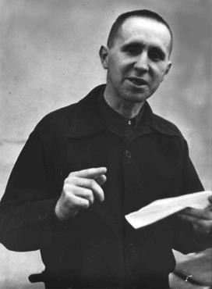
Criterion D:
Responding

Achievement level | Level descriptor | Clarifications
0 | - The student does not reach a standard described by any of the descriptors below.
1 – 2 | - The student:  - presents a limited outline of connections and may transfer learning to new settings  - creates a limited artistic response which is possibly inspired by the world around him or her  - presents a limited evaluation of the artwork of self and others. | Process Journal  .  - Your artistic response to your research on your chosen social issue was not clearly evident in your final Epic Theatre performance.  - There is limited evaluation of the work of yourself or your peers evidenced in your journal.
3 – 4 | - The student:  - presents an adequate outline of connections and occasionally transfers learning to new settings  - creates an adequate artistic response which is occasionally inspired by the world around him or her  - presents an adequate evaluation of the artwork of self and others. | Process Journal  - There was some evidence of your artistic response to the social issue research evident in your final Epic Theatre performance.  - There is some evaluation of the your work and the work of your peers evidenced in your journal.
5 – 6 | - The student:  - presents a substantial outline of connections and regularly transfers learning to new settings  - creates a substantial artistic response which is regularly inspired by the world around him or her  - presents a substantial evaluation of the artwork of self and others. | Process Journal  - Your artistic response to the research conducted on your chosen social issue was clearly evident in your final Epic Theatre performance.  - There is detailed evaluation of the your work and the work of your peers evidenced in your journal.
7 – 8 | - The student:  - presents an excellent outline of connections with depth and insight, and effectively transfers learning to new settings  - creates an excellent artistic response which is effectively inspired by the world around him or her  - presents an excellent evaluation of the artwork of self and others. | Process Journal  - Your artistic response to the research conducted on your chosen social issue clearly inspired the creative decisions you made in your final Epic Theatre Performance.  - There is detailed evaluation of your work and the work of your peers evidenced in your journal, which clearly influences your creative process.

