Performance Planning Questions

A Tell Tale Heart

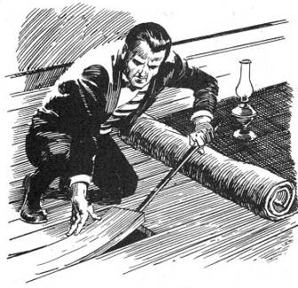

Please answer the following questions individually on this document.

Your planning will be assessed as part of your Criteria A task so please attach this document to your drama website.

WEBSITE PAGE TITLE: Group planning document

- Which moments from the story are you going to devise?

- Which additional scenes are you going to use to communicate the story or atmosphere? (E.g. are you going to create any abstract scenes that communicate the feelings of a character or devise a news report that provides an extension to the original story?)

- Which specific drama skills and techniques do you plan to use in your performance?

Dramatic Pauses Tableaux

Split Scene Gestus

Direct Address Physical Theatre

Narration Chorus

Mime Placards/Projections

Other:

- Explain when you are going to use music or sounds in your performance. (Be specific- explain what piece/s of music or sounds you will you use at specific points in the performance.)

- Explain why you chose these moments to add music. By using this music, what is the desired mood you wish to communicate?

- Which lighting state/s would you like to use for your performance? Please explain why. (Refer back to your notes on lighting design from the previous lesson to help you answer this question.)

