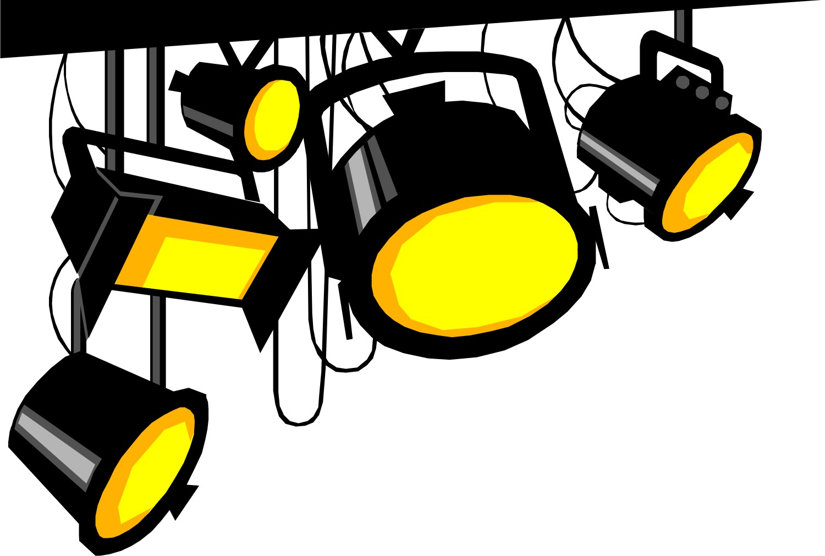How can lighting design communicate
meaning to an audience?

Task: Watch six versions of one mime performance with music. Each version will use a different lighting design.

For each version please write down your thoughts below on how the lighting design affects the performance. How does it influence the mood of the performance? Does it make you think of a particular setting for the scene?

- Red
_____________________________________________________________________________________________________________________________________________________________________________________________________________________________________________________________________________________________________________________________________________________________________________________________________________________________________________________________

- Smoky Night
_________________________________________________________________________________________
____________________________________________________________________________________________________________________________________________________________________________________________________________________________________________________________________________________________________________________________________________________________________

- Night
_____________________________________________________________________________________________________________________________________________________________________________________________________________________________________________________________________________________________________________________________________________________________________________________________________________________________________________________________

- Shadows
_____________________________________________________________________________________________________________________________________________________________________________________________________________________________________________________________________________________________________________________________________________________________________________________________________________________________________________________________

- Yellow
_____________________________________________________________________________________________________________________________________________________________________________________________________________________________________________________________________________________________________________________________________________________________________________________________________________________________________________________________

- Low
_____________________________________________________________________________________________________________________________________________________________________________________________________________________________________________________________________________________________________________________________________________________________________________________________________________________________________________________________

Which lighting design would you choose for the performance of your own mime? Please explain your answer.

_________________________________________________________________________________________
_________________________________________________________________________________________
_________________________________________________________________________________________
_________________________________________________________________________________________
_________________________________________________________________________________________
_________________________________________________________________________________________
_________________________________________________________________________________________

